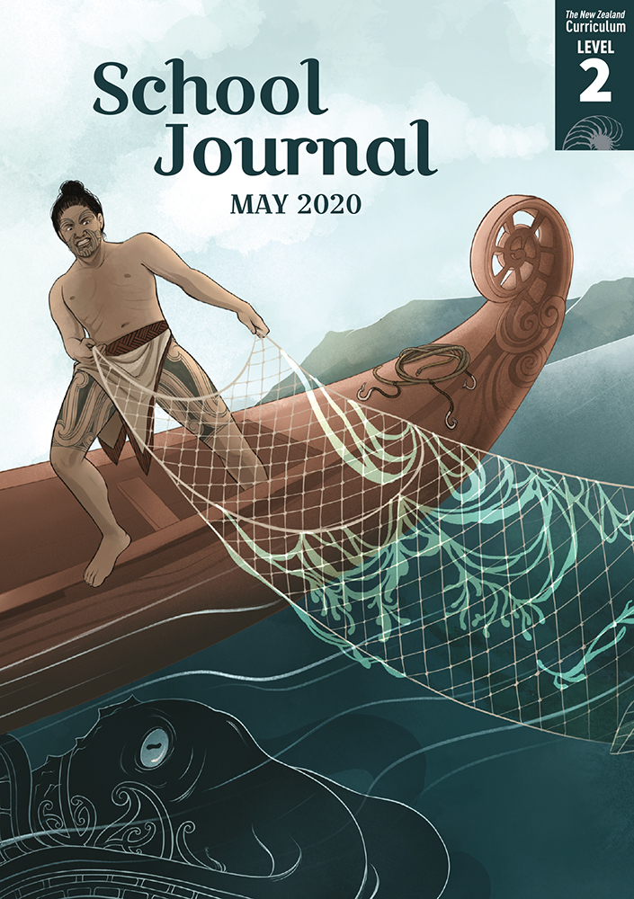­

School Journal

Level 2, May 2020

**Year 4**

# Kupe and the Giant Wheke

a traditional story, retold by Steph Matuku

The[Learning Progression Frameworks](https://curriculumprogresstools.education.govt.nz/lpf-tool) describe significant signposts in reading and writing as students develop and apply their literacy knowledge and skills with increasing expertise from school entry to the end of year 10.

## Overview

This traditional tale features in the oral traditions of many iwi. It tells of how Kupe discovered Aotearoa while pursuing a giant wheke (octopus) across the Pacific. As he chased the creature around Aotearoa, Kupe explored the new land and named many places.

A PDF of the text and an audio version as an MP3 file are available at [www.schooljournal.tki.org.nz](http://www.schooljournal.tki.org.nz)

## Themes

* Bravery and courage
* Tangata whenua
* Oral traditions
* Magic

## Related texts

“**Kurī”** SJ L2 Oct 2015 | “**The Sons of Ma‘afu**” SJ L2 Oct 2015 | “**Baskets of Fire**” SJ L2 Nov 2018 | “**Awarua: The Taniwha of Porirua**” SJ L2 May 2016 | “**Kōpūwai and the Clever Girl**” SJ L3 May 2017 | “**Monsters**” SJ L2 May 2020

## Strengthening reading behaviours (what to notice)

|  |  |
| --- | --- |
| Text structure and features | Requiring students to: |
| * Implied information or ideas * Unfamiliar vocabulary and words in te reo Māori | * infer that Kupe’s rival, Muturangi, also possesses magical powers, that the octopus is a monstrous size, and that the author’s purpose is to explain Kupe’s journey across the Pacific and his eventual discovery of Aotearoa * use other resources, such as the map and contextual clues, to work out unfamiliar vocabulary, including the use of te reo Māori place names. |

|  |  |
| --- | --- |
| Vocabulary | |
| Possibly unfamiliar words and phrases | grim, slime, octopus, bait, snapped, mimicked, calabashes, tempt, slimy, tentacle, yanked, chanted an incantation, mere, towering, on the loose, wily, cornered, slipped out, splintered, shudder, limp |
| Names of people and places in te reo Māori | Kupe, Hine-Te-Aparangi, Hawaiki, Muturangi, Te Wheke, Tauaru, Rangiwhakaoma, Hokianga, Whanganui-a-Tara, Te Moana o Raukawa, Ngā-rā-o-Kupe, Te Taonui-o-Kupe, Te Umu Wheke |

|  |
| --- |
| Helpful prior knowledge (pre-reading and introducing the text) |
| * Traditional tales have some common features, including characters with magical powers and tasks to complete. * Traditional tales are sometimes used to explain the formation of geographical features (and their names). * Kupe is regarded by most Māori as the first person to discover and explore New Zealand. * Māori trace their ancestry back to Hawaiki, and Kupe is regarded as coming from there. |

## Possible reading and writing purposes

* Read and enjoy a story about how Kupe found Aotearoa
* Locate and record information about the journey Kupe and his whānau took across the sea
* Identify, record, and organise the features of a traditional tale

See *Effective Literacy Practice in Years 1–4* for suggestions on using this text with your students ([Approaches to teaching reading](http://literacyonline.tki.org.nz/Literacy-Online/Planning-for-my-students-needs/Effective-Literacy-Practice-Years-1-4/Approaches-to-teaching-reading)) and for information about teaching comprehension strategies ([Building comprehension](http://literacyonline.tki.org.nz/Literacy-Online/Planning-for-my-students-needs/Effective-Literacy-Practice-Years-1-4/Building-comprehension) and [Text processing strategies](http://literacyonline.tki.org.nz/Literacy-Online/Planning-for-my-students-needs/Effective-Literacy-Practice-Years-1-4/Text-processing-strategies)).

## Possible curriculum contexts

This text has links to level 2 of the New Zealand Curriculum in:[**ENGLISH**](http://nzcurriculum.tki.org.nz/The-New-Zealand-Curriculum/English)[**SOCIAL SCIENCES**](http://nzcurriculum.tki.org.nz/The-New-Zealand-Curriculum/Social-sciences)

## Understanding progress

The following aspects of progress are taken from the [Learning Progression Framework](https://curriculumprogresstools.education.govt.nz/lpf-tool/)s and relate to the specific learning tasks below. See the LPFs for more about how students develop expertise and make progress in these aspects:

* Reading for literary experience
* Making sense of text: using knowledge of text structure and features
* Reading to organise ideas and information for learning
* Creating texts for literary purposes
* Using writing to think and organise for learning.

## Strengthening understanding through reading and writing

The *School Journal* provides rich texts that can be returned to many times. The following suggestions are based on the premise that rereading the text is a fundamental part of developing students’ understanding and reading skills. **Select from and adapt** them, according to your students’ strengths, needs, and experiences.   
Note: Most of these activities lend themselves to students working in pairs or small groups.

* Review the features of a traditional tale. Have the students use the **Retelling** template provided to summarise these features and the story, drawing the main events and adding text. They could also use this template to support a retelling, orally or in writing, or to plan their own writing.
* Alternatively, the students could sequence and retell the story using images from the text for support.
* Ask the students to each write a 5WH question about an aspect of Kupe’s journey, for example, “Why did they go?”, “What was the journey like?”, “Where did they end up?”. Write these questions on a chart. Reread the tale to locate the parts that give information about Kupe’s journey. The students might use small stickies to mark any information. Together, share what they have marked to answer the questions.
* Identify the magical aspects of this story, think about and explain possible reasons why these are included in a traditional tale, and discuss what the tale might be teaching or explaining.
* Create a T-chart to explore the different views the characters have of Te Wheke.
* Draw either Muturangi or Kupe in the centre of a page. Find the words and phrases in the tale that show what they are like. Encourage the students to add words of their own.
* Make connections with an aspect of the story, for example, being in a waka, fishing, or being out at sea, and write about it.
* Innovate on the story of Kupe, creating another encounter with Te Wheke before the octopus was finally killed, using some features of traditional tales.
* Read other stories about Kupe, wheke, traditional tales about Aotearoa, or about your own area.
* Explore unfamiliar or interesting vocabulary. The students could make a word web of related words about bravery, waka, words to do with tangata whenua, or the places mentioned.  
  A verb story activity will help English language learners to notice the use of verbs. List all the verbs in a section of text in order on the whiteboard. As a group, read the section of text together chorally two or three times. Then, ask the students to use the verbs as a prompt to retell that part of the story. The retelling can be completed by a whole group or each student could take turns to add a sentence. Repeat as often as necessary until the students can retell it fluently.
* For more ideas and strategies to support English language learners, see [ESOL Online](https://esolonline.tki.org.nz/).

“Kupe and the Giant Wheke” Retelling

**Title: Author (often retold by):**

|  |
| --- |
| The story sequence: |

|  |  |  |  |  |  |  |
| --- | --- | --- | --- | --- | --- | --- |
| 1 |  | 2 |  | 3 |  | 4 |
|  |  |  |  |  |  |  |

|  |  |  |  |  |  |  |
| --- | --- | --- | --- | --- | --- | --- |
| 5 |  | 6 |  | 7 |  | 8 |
|  |  |  |  |  |  |  |

|  |
| --- |
| This story is explaining … |